Great Job team:-)))

1. **Dealing with missing values -**

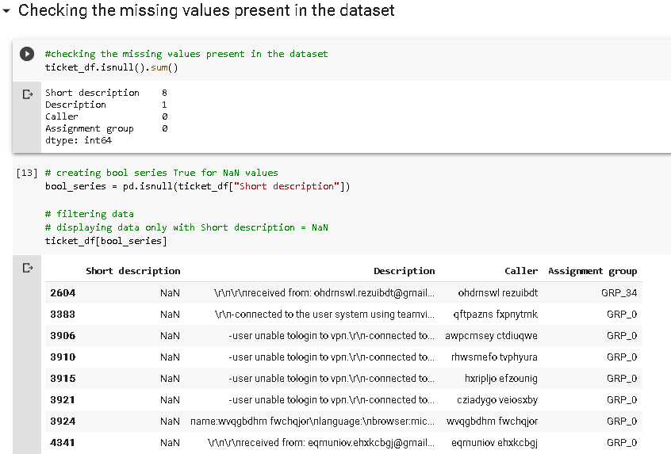

**Suggestions**:

1. Since 8 short descriptions are missing - fill them with the first 10-15 words from the Description field.
2. Since 1 description is missing - fill it with the short description field text OR drop that entry.
3. **Dealing with Junk values and data cleaning:**

**Suggestions:**

1. The re. sub() function in the re module can be used to replace substrings.

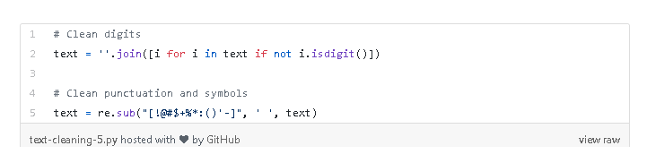

1. We require to use text-pre processing techniques.
2. Removing punctuations.
3. Remove stop words
4. Lemmatization or Stemming
5. Tokenization
6. Encoding the ‘Caller’ data since visually it is intimidating

Without this, visualizing data wont be efficient.

I suppose we can consider importing the NLTK library to do the same.

The examples from the course cover this part.

**Readings:**

[**https://www.kdnuggets.com/2018/03/text-data-preprocessing-walkthrough-python.html**](https://www.kdnuggets.com/2018/03/text-data-preprocessing-walkthrough-python.html)

[**https://medium.com/@dobko_m/nlp-text-data-cleaning-and-preprocessing-ea3ffe0406c1**](https://medium.com/@dobko_m/nlp-text-data-cleaning-and-preprocessing-ea3ffe0406c1)

[**https://towardsdatascience.com/nlp-for-beginners-cleaning-preprocessing-text-data-ae8e306bef0f**](https://towardsdatascience.com/nlp-for-beginners-cleaning-preprocessing-text-data-ae8e306bef0f)

**27-March 2020**

**TODOs 🡪**

1. Removal of duplicates – 83 in the entire dataset.
2. Insert code for Label encoding Caller data into the main baseline file
3. Stemming to be implemented
4. Word cloud for text processed vocab not present in EDA file
5. Language translations – G’s file, has to be included into the main file
6. @Team, any fields that are not present in the Dataset that would have been helpful besides the ones I stated.

**Others for Milestone 2:**

1. Neural nets and transfer learning modelling
2. Word embeddings besides TF-iDF Vectorization deferred for later..Word embeddings using Word2vec and Glove
3. Point Dataset to the Github repo
4. Split code into .py packages
5. Each group feature extraction of Description/ Summary